Comparison between India and South Korea in terms of growth, innovation, and development

**Objective:**

We intend to identify “how India as a developing nation may catchup or converge to the developed economies like South Korea as did so far”. This perspective is extremely useful nowadays since developing countries need not only to develop at domestic level but under the strong pressure and competition of globalization. The comparative analysis identified that India lags behind in various important sectors including Education, R&D and some other correlated sectors including corruption.

**South Korea as an Asian Tiger:**

Also known as the Asian Dragons, the countries that make up the Four Asian Tigers share common characteristics, including a sharp focus on exports, an educated populace, and high savings rates. Since the second half of the twentieth century, most domineering experience in the rise of the global economy had been the upswing of East Asian industrializing countries including South Korea. In the 1960s, South Korea's per capita gross domestic product was comparable to the poorest countries in Asia and Africa. But in the four decades since then, the country has observed substantial growth, affected in part by a system of close government, directed credit, and import restrictions. As of April 2023, South Korea had a total GDP of $1.72 trillion and a per capita GDP of $33,390 with a growth rate of 1.5% and a population of 51.6 million. Korea made impressive and enormous strides in the fields, especially Capital formation, Manufacturing, Trade mainly exports and Innovation (R&D), controlling red tape, which in turn helped them a great deal in the overall development. The empirical study makes it that Education, Trade, Manufacturing, R&D that augmented the development process in Korea and made it a replicable model, may also prove the same for India if followed sensibly. The rapid overall and inclusive growth and development of South Korea makes it unique and forces a close study of the comparison of macroeconomic measures.

**India and Korea ~ similarities and differences in policy framing, growth rate, and per capita income:**

Although India and Korea shared similar features at the beginning of their reforms as same growth rates, and per capita income, Korea succeeded in pushing up its economic growth and income, utilized US and Japan model, aid and resources in an appropriate manner. Indian reforms start late due to domestic and foreign problems. Since independence, India initiated several strategies for its economic development process mainly through their several annual and five-year plans. Even though the mentioned plans did target some of the sectors to speed up the pace of development, most of the plans have failed and have reached nowhere close to their targeted outcome.

For example, India’s Jan Dhan Yojna is the world’s most extensive financial inclusion scheme to bring banking services to every adult. But two out of five people are self-employed, and it takes a long month and ten days on average to start a business with endless red tape and corruption.

India ranks 87th while South Korea ranks 15th in Index of Economic Freedom, 2023.

The GDP growth rates in both countries were more or less the same in 1962, 2.7 percent for India and 2.1 percent for South Korea (Reddy, 2003). Within less than forty years, Korea’s rate of growth started increasing rapidly at around 9 to 10 percent. No other country showed such a rapid growth. India was clearly lagging far behind and was viewed as the development malfunction, but over the past few decades, India has achieved more progress and going to be a fast-growing economy.

In terms of sectoral growth, both the countries recorded highest growth rates in the industrial sectors of their respective economies. During this decade, both India and South Korea grew in the industrial sector. India recorded higher growth rate only in agriculture sector but industrial and service sectors growth rates were much higher in the Korean economy.

The growth rates of India and Korea were converged during the decade of the 1990s. India’s GDP growth rate was marginally higher (6 per cent per annum), whereas Korea’s GDP growth rate was 5.8 per cent per annum. East Asian financial crisis that occurred towards the end of this decade (1997- 98), severely affected Korean economy.

Service sector was the fastest growing sector in India but manufacturing sector remained the leading sector in Korean economy. Indian economy surpassed the Korean economy in terms of GDP growth rates as well as in all the sectoral growth rates in the first decade of the 21st century. The service sector emerged in the Indian economy as the ‘engine of growth’.

**Reason behind South Korea having a higher rate of economic growth:**

The high rates of economic growth of Korean economy over a longer period of time are expected to change the production structure of its economy. The Korean economy followed the standard patterns of economic development as has been observed by the advanced countries. Indian economy skipped the phase of industrialization and prematurely turned towards service-oriented economy even at a very low level of per capita income.

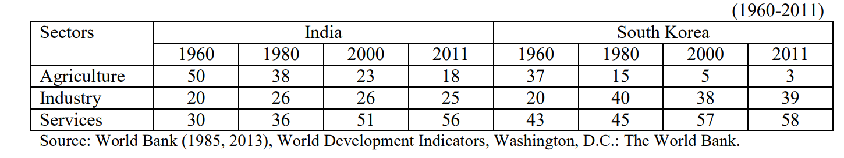

Korea and India have been transforming their economies though at a different rate. The structural transformation and economic development process involved multiple factors. Korea’s fast pace of catch up has been essentially attributed to its highly developed capacity to absorb and use of new technology developed elsewhere (Lundvall, 2011). A remarkable distinction has been made between active and passive learning system. Korea has enacted and followed active system of learning which has been attributed to the successful transition of her economy while the slow economic transformation of the Indian economy can be linked to passive learning systems. The development process in both countries involves the absorption and use of innovations developed in the advanced countries to develop their own systems of innovation.

**Comparison of GDP and Gross Fixed Capital Formation of India and South Korea ~ a graphical interpretation:**

The growth rate of India shows somehow stationary trend till 1990 and gradually started to grow since the 1990s. The growth of India stood higher from 2006 to 2010 at 8.33 percent. After the global financial crisis of 2008, the Korean growth rate had started declining while India is showing an increasing trend as India got relatively least affected by the said crisis. In 2011-13, India was at the better position than that of the Korea in GDP growth. Since then, India’s GDP has remained higher than that of South Korea, as is visible from the graph.

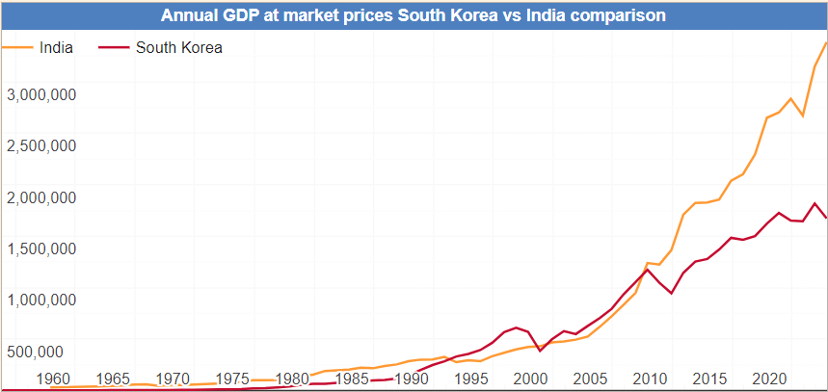

Fixed Capital Formation in India decreased to 14008.32 INR Billion in the second quarter of 2023 from 15380.71 INR Billion in the first quarter of 2023. Gross Fixed Capital Formation in India averaged 7008.31 INR Billion from 2001 until 2023, reaching an all-time high of 15380.71 INR Billion in the first quarter of 2023 and a record low of 2021.90 INR Billion in the first quarter of 2002.

Gross Fixed Capital Formation in South Korea increased to 145563 KRW Billion in the third quarter of 2023 from 145049.60 KRW Billion in the second quarter of 2023. Gross Fixed Capital Formation in South Korea averaged 55924.25 KRW Billion from 1960 until 2023, reaching an all-time high of 146111.40 KRW Billion in the fourth quarter of 2022 and a record low of 376.00 KRW Billion in the fourth quarter of 1960.

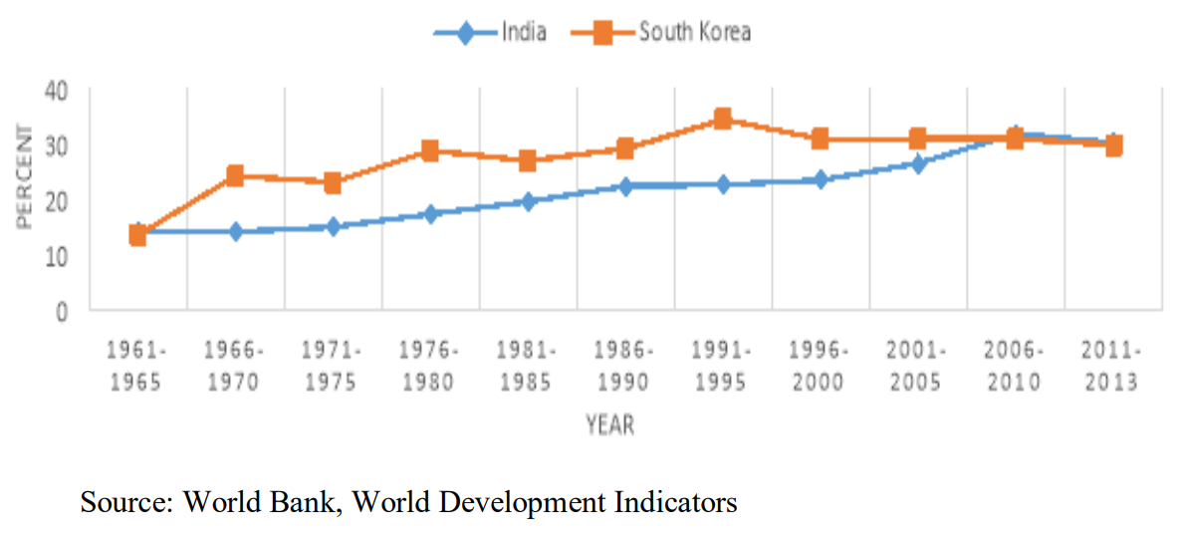

Throughout 1966-2005, Korea remained ahead of India while after 2005-2013 both stood more or less at the same spot. From this, it can be depicted that at present, India is growing towards the fast-growing economy with gaining momentum in investment activities.

**Discussion of how South Korea has surpassed India in terms of external performance ~ a data analysis:**

India’s trade during the initial period shows the dismal performance as it was the closed economy. Up to 1990, there is a decelerating performance shown in the import and export sectors. The share of imports and exports up to 1990 fluctuate between 5 percent to 7 percent and 3 percent to 6 percent respectively. After 1961-65, the developmental and growth strategies of Korea had surpassed India in every sphere of external performance. Here it is depicted from the data that difference is less in the case of imports whereas difference is much higher in the case of exports.

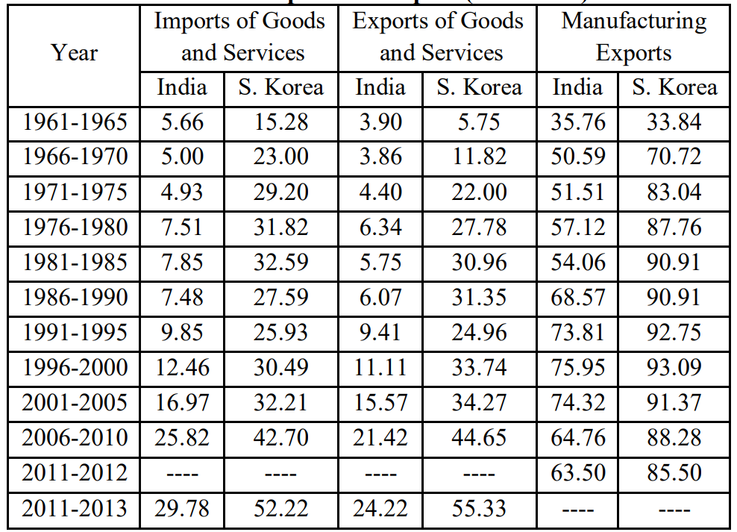

In 2011-13, the difference stood at 21.11 percent in the case of exports of goods and services, 22.44 percent in the case of imports of goods and services and 22.0 percent in the case of manufactured exports. As stated earlier that during 1960s Korea had shifted their focus from agriculture to industrialization and urbanization.

The capital inflow was greatly encouraged to complement the shortage of domestic savings which made the South Korea achieve such a rapid growth in exports and consequent increase in income (A.M & Shaw, 1997).

India possesses a comparative advantage in pharmaceutical products (Manisha and Kaur, 2016) and in information technology (Bhan and Bhatia, 2016). India may utilize with appropriate policies and with available technology and resources to generate sufficient employment and exports to deal with current account deficit problems and increase in global trade share. Again, Indian receives huge remittances from migration, which, if utilized in a desirable manner will lead to poverty reduction, but unfortunately had not been seen so far.

**Graphical representation of Research and Development trends in India and South Korea:**

Korea had given much more importance to the innovative and technological based economy as is depicted from their behaviour of investing in R&D activities. Korea pays attention to the development of basic institutions for the adaptation of foreign technology. Among them, the Ministry of Science and Technology (MOST), and the Korean Institute of Science and Technology (KIST), a government R&D facility are dedicated to applied technology.

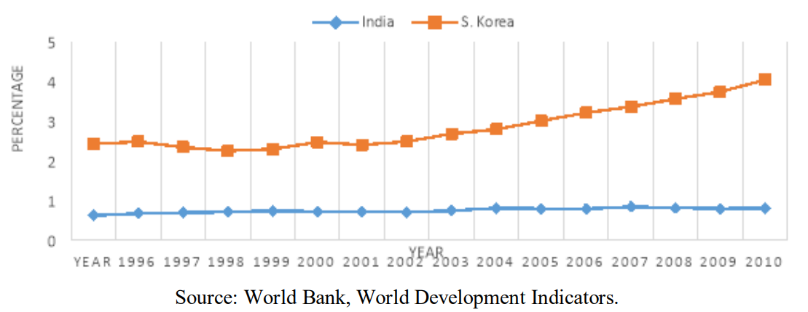

During 1996-2011, India’s R&D expenditure to GDP ranges between 0.6 to 0.8, which shows negligible efforts to modernize and attain the pace of developmental activities of Indian economy. On the other hand, Korea having the highest R&D expenditure even among “OECD” countries, had the leading edge in and technology on par with many highly advanced countries like Australia, China, Israel, Japan, New Zealand, Russian Federation, Singapore, UK and the USA. As discussed earlier that R&D had a considerable impact on high tech manufacturing exports as seen from Korea.

**A deeper analysis of why India is failing to be at par with South Korea:**

There is a lack of coordination among seats of the higher learning, i.e. quaternary sector and highest decision-making body, i.e., Quinary sector in India. This was quite evident from recent Demonetization drive by India on 8th of November 2016 for which growth forecast was trimmed by IMF for the current and next financial year from 7.6 to 6.6 percent. This was mainly on the reasons for the slowdown in economic activities and negative consumption by cash shortage and payment disturbances connected with recent cash withdrawal.

The failure and dismal of administrative and executive performance of India as reflected arises because of the ministers with key portfolios under the heinous scandals. Korea, as compared to India, had got better scores in each and every aspect depicts their well maintained and strict law and order in practice.

**Error Correction Model for India:**

An error correction model (ECM) belongs to a category of multiple [time series](https://en.wikipedia.org/wiki/Time_series) models most commonly used for data where the underlying variables have a long-run common stochastic trend, also known as [cointegration](https://en.wikipedia.org/wiki/Cointegration). ECMs are a theoretically-driven approach useful for estimating both short-term and long-term effects of one time series on another. The term error-correction relates to the fact that last-period's deviation from a long-run equilibrium, the error, influences its short-run dynamics.

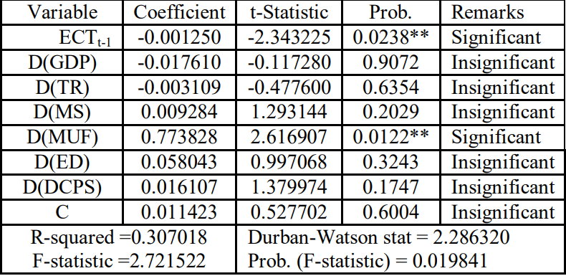

ECTt-1 coefficient with a negative value which is (-0.001250) indicates the very high speed of convergence towards equilibrium. The overall result shows a significant presence of an error correction in the equation and its negative sign suggests that at whatever time there is a disequilibrium, GDP regulates towards equilibrium to be restored as market forces both domestic and foreign are in operation. Empirical results reveal that manufacturing is significant in short run affecting the GDP. So, there is a need to promote the competitiveness of the Indian manufacturing sector at the global level, which is imperative for the sustainable growth, employment generation and the success of the ‘MAKE IN INDIA’ campaign by eliminating the unnecessary rules and regulations.

**VAR test for South Korea:**

Vector autoregression (VAR) is a statistical model used to capture the relationship between multiple quantities as they change over time.

The findings from the South Korea display that GDP is enhanced by the capital formation and money supply, and trade. Education had an important impact on the further betterment in education investment as concluded from the comparison with India.

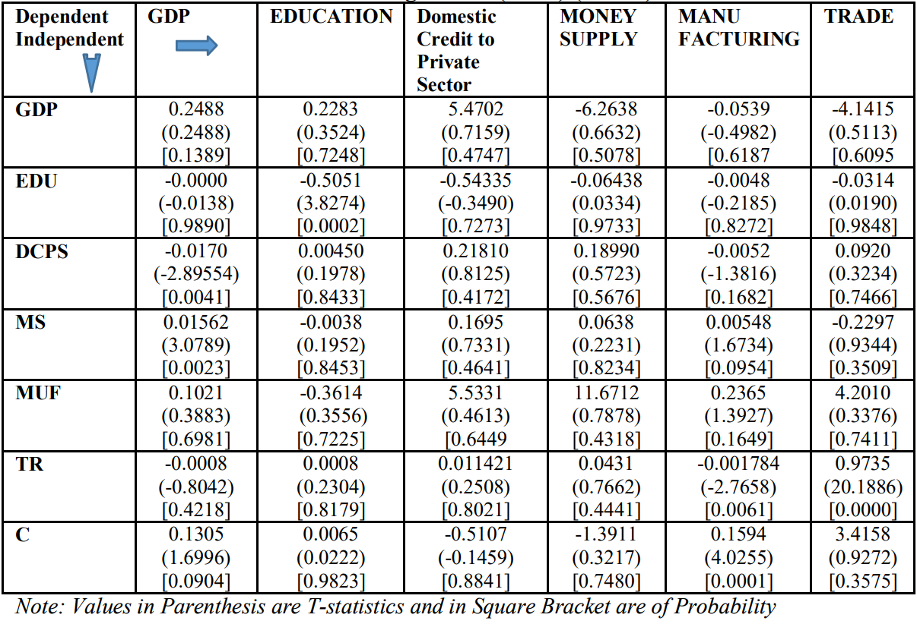

**Conclusion:**

India and Korea embarked on the modern economic development path at the same time and under almost similar global economic environment. Korea’s sustained economic growth experience during the 1960s, 1970s and 1980s has transformed it from a low-income country to a high-income industrialized country. However, India’s growth experience during the last six decades only allowed it to change its position from a low income to a low medium income country in the global economy. Nonetheless, Indian and Korean growth rates converged in the 1990s and India has surpassed the Korean growth rates in the first decade of the 21st century.

Korea’s heavy and chemical industries promotion plan is well documented in revealing the intent of government to achieve economic growth and international competitiveness.

Korea has gone ahead due to raising R&D intensity multiple times and also inducing company level intensity in R&D. The analysis of sustained growth and disruption of economic growth momentum both in Korea and India gives credence to the view that a more inclusive view of national systems of innovation presents an optimal combination of the state and the market that deliver and sustain economic growth. The comparative analysis of growth, structure and systems of innovation brings out many lessons that can be learnt from both the countries.